Choose and Book Referral Status:
Use Case Model
Amendment History:
Version | Date | Amendment History
0.1 | 20/12/2005 | First draft for comment
0.2 | 20/12/2005 | Updated with comments from Mark Byrne
0.3 | 22/12/2005 | Updated with comments from Ross Dixon and Simon Withey
0.4 | 23/12/2005 | Updated after review meeting of 22/12/2005.
1.0 | 10/01/2006 | Approved version
1.1 | 08/02/2006 | Update to include details of uninitialised request
1.2 | 13/02/2006 | Updated with comments from Mark Byrne
2.0 | 17/02/2006 | Approved version
Forecast Changes:
Anticipated Change | When
Reviewers:
This document must be reviewed by the following. Indicate any delegation for sign off.
Name | Signature | Title / Responsibility | Date | Version
Paul Stitt |  | Technical Architect, Choose and Book
Simon Withey |  | Head of Business Requirements & Implementation Support
Mark Byrne |  | Technical Architect, Choose and Book

Approvals:
This document requires the following approvals:
Name | Signature | Title / Responsibility | Date | Version
Chris Elkins |  | Future Development Manager, Choose and Book
Ross Dixon |  | Senior Business Architect, Business Requirements Team
Distribution:
Reviewers and Approvers.
Document Status:
This is a controlled document.
Whilst this document may be printed, the electronic version maintained in FileCM is the controlled copy. Any printed copies of the document are not controlled.
Related Documents:
These documents will provide additional information.
Ref no | Doc Reference Number | Title | Version
1 | NPFIT-SHR-QMS-PRP-0015 | Glossary of Terms Consolidated.doc | 11
2 | NPFIT-SHR-MODL-GUID-0001 | Process Modelling Authoring Guide | 04
3 | NPFIT-ELIBR-AREL-P1R2-0121 | Message Implementation Manual | 01
4 | NPFIT-SHR-MODL-GUID-0004 | Process Modelling User Guide | 02
5 | NPFIT-EBS-DES-0015.05 | Choose and Book Service Manual | 05
6 | NPFIT-NCR-2006b-REQ-0013 | Volumetric Requirements 2006-B Issue 1 Draft D | 01
7 | NPFIT-EBS-DES-0036 | Choose and Book Compliance V5.0 | 03
8 | NPFIT-SHR-MODL-GUID-0008 | Communications Requirements Design Guide | 01
9 | NPFIT-SHR-MODL-CHB--0001 | Choose and Book Referral Status Scope Document | 01
10 | NPFIT-SHR-MODL-CHB-0002 | Choose and Book Referral Status Model (Native) | 01
11 | NPFIT-SHR-MODL-CHB-0003 | Choose and Book Referral Status Model (HTML) | 01
12 | NPFIT-FNT-TO-DQN-0102 | Advice on handling ‘Flagged’ records on PDS | 01
13 | NPFIT-EBS-DES-0075 | Choose and Book Referral Message Guidance | 05
Glossary of Terms:
List any new terms created in this document. Mail the NPO Quality Manager to have these included in the master glossary above [1].
Term | Acronym | Definition

Contents
1 About this Document 5
1.1 Purpose 5
1.2 Audience 5
1.3 Content 5
1.4 Terminology 5
2 Choose and Book Referral Status 6
2.1 Overview 6
2.2 Use Case Model 8
2.3 Use Case Elaboration 9
2.3.1 Introduction 9
2.3.2 Actor: Enquirer 9
2.3.3 Use Case CAB1: Find Patient 9
2.3.4 Use Case CAB2: View Referral Outline Information for Patient 10
2.3.5 Use Case CAB3: Find UBRN 11
2.3.6 Use Case CAB4: View Details of Specific Referral 12
2.3.7 Use Case CAB5: Retrieve Referral Outline Information 13
2.3.8 Use Case CAB6: Retrieve Details of Specific Referral 16
3 Validation of access to patient data in Choose and Book 19
3.1 Overview 19
3.1.1 The patient 19
3.1.2 Primary care 19
3.1.3 Secondary care 19
3.1.4 Stop-noted patient 19
3.1.5 Validation rules for Choose and Book referral status outline information 20
3.1.6 Validation rules for Choose and Book referral detail information 20

About this Document

Purpose
The purpose of this document is to define using a series of use cases the functionality described in [9]. Specifically this is the interactions required to allow an external application to obtain information from Choose and Book about a particular patient’s referrals and requests for advice and guidance.
A use case model is followed by a series of use case elaborations giving an overview of the intended functionality.

Audience
The primary audience of this document are the team who generate message designs. Detailed knowledge of Choose and Book is therefore not assumed.

Content
This document comprises
- Use case model for Choose and Book referral status actions
- Use case elaborations for each of the use cases in the model
- An explanation of the validation rules used to determine what patient data a user of Choose and Book may access. These rules will apply equally to users accessing the information via third-party systems

Terminology
For simplicity in this document, both referrals and requests for advice and guidance are referred to as referrals.
All requests to retrieve information from Choose and Book will require the user of the calling application to be uniquely identifiable and validated by Choose and Book. In the case of professional users, it is assumed the role profile code (RPC) will be passed to Choose and Book to allow this happen. In the case of patient users, it is assumed that the patient’s NHS number will be provided. For simplicity in this document, this ID is referred to as ‘the unique identifier of the enquirer’, without specifying what this is.

Choose and Book Referral Status

Overview
Three types of system have initially been identified which may require an interface to Choose and Book in order to investigate the status of a patient’s referrals. These are the GP systems used in primary care, the Patient Administration systems used in secondary care and Healthspace, the patient self-care system. However, other systems in future may also make use of the interface and thus the identity of the calling application and its functionality has been kept generic and described only at a high level.
Two scenarios are initially envisaged:
- A user of the calling application wishes to view outline information about the patient’s referrals held in Choose and Book. The calling application communicates with Choose and Book in order to retrieve this information.
- A user of the calling application wishes to view the details of a particular referral held in Choose and Book. The calling application communicates with Choose and Book in order to retrieve this information.
It is not assumed that the calling application will perform the first scenario as a prerequisite to the second scenario; these are regarded as independent processes as far as Choose and Book is concerned. It is possible that some (or all) of the calling applications will retrieve the UBRN of the referral whose detail is sought from Choose and Book first – see section 2.3.5 for alternative possibilities.
It is, however, assumed that any calling application will be PDS compliant and thus the patient’s NHS number will be validated in PDS before any request is made of Choose and Book.
A number of factors influence what information the enquirer may retrieve from Choose and Book. This is detailed in section 3. Many of the possible scenarios detailed in section 3 are either very unlikely or it is assumed the calling application would prevent the user from carrying out an invalid action. For example, it is unlikely that an administrative user would be able to request clinical information about a patient’s referral. Nevertheless, Choose and Book will validate the request for completeness.
Note that only a certain amount of historical data is held in Choose and Book and it will only be possible to retrieve details of those referrals currently held in the system at the time of the enquiry. An attempt to retrieve details of a referral which has been archived will result in an error. Currently this document assumes that the error will be different from the error which would result in a request to view details of a referral using a UBRN which has never existed in Choose and Book..
A referral will exist in Choose and Book in a skeleton state after a compliant GP system has sent a request for service, which will create a new referral and populate some basic details, returning a Unique Booking Reference Number (UBRN) to the GP system. Thereafter the GP will launch Choose and Book and be navigated automatically to the context of the UBRN to add sufficient detail to make this referral a valid appointment request or request for advice and guidance.
An uninitialised request should not therefore persist in Choose and Book. However, it is possible that it will exist in this state at the time that a calling application requests details of the patient’s referrals. This may be because the unintialised request could not be completed due to technical problems, or that another user makes a query about the patient before the uninitialised request is initialised.
The only significance of this within the scope of this project is that an uninitialised request will not have any clinical information associated with it. Requesting clinical information about the uninitialised request will not cause an error to occur, see section 2.3.8.

Use Case Model
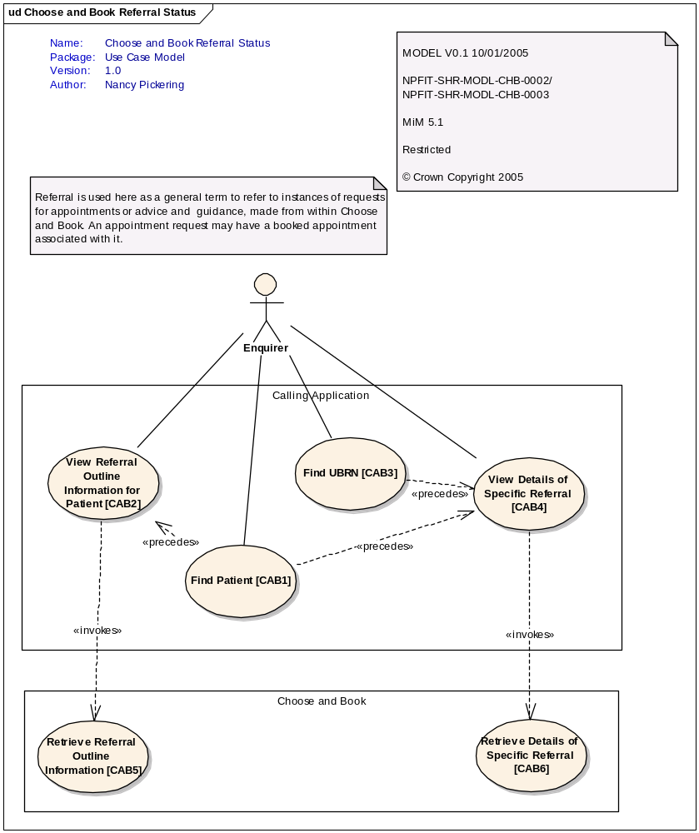
Figure 1 - Choose and Book Referral Status Use Case Model

Use Case Elaboration

Introduction
Each use case and actor in the above model is elaborated below. The use cases defined in the Calling Application are not described in detail; as noted in section 2.1, a number of different applications may make use of the interface to Choose and Book and each may operate differently. Only the functionality required in order to access the information held in Choose and Book is therefore described.

Actor: Enquirer
The enquirer is a person who wishes to see information about a patient’s referrals held in Choose and Book. The enquirer may be one of a number of different people interacting with different systems and with different levels of access to the patient’s data. This is outlined in more detail in section 3.1.
In order to validate what information the enquirer may view about the patient’s referrals, a code uniquely identifying the enquirer will be communicated to Choose and Book for each enquiry. It is anticipated that in the case of a patient this will be the patient’s NHS number, and in all other cases the role profile code (RPC) of the enquirer.
It is assumed that any application used by patients to access data held in Choose and Book will be sufficiently robust in terms of authentication that it can be treated as a trusted client and so providing the patient’s NHS number as a unique identifier of the user will be sufficient.

Use Case CAB1: Find Patient
Use Case Name | Find Patient
Identifier | CAB1
Summary Description:
The enquirer obtains the NHS number of the patient whose referral information is sought.
Actors | Enquirer
Triggering Event | The enquirer wishes to access information about a particular patient.
Other Inputs | None
Outputs and  Products of Value | The patient’s NHS number is obtained.
Main path(s):
- The enquirer performs a look-up in the calling application to obtain the patient’s NHS number
Alternate path(s):
- The enquirer already has the patient’s NHS number.
External Interactions | N/A
Notes:
.

Use Case CAB2: View Referral Outline Information for Patient

Use Case Name | View Referral Outline Information for Patient
Identifier | CAB2
Summary Description:
The enquirer wishes to view a list of the patient’s current referrals based on the information held in Choose and Book. The system which the enquirer is using interrogates Choose and Book for this information and presents the results to the enquirer.
Actors | Enquirer
Triggering Event | The Enquirer wishes to view outline information about a patient’s referrals and has access to the patient’s NHS Number.
Other Inputs | - Validation rules will be used to determine which, if any, of the patient’s referrals the enquirer may view. These validation rules are given in the table in section 3.1.5.
Outputs and  Products of Value | A list of the patient’s referrals is returned from Choose and Book.
Main path(s):
- The enquirer selects an option in the calling application to view a list of outline information about a patient’s referrals.
- The calling application issues a communication to Choose and Book containing the patient’s NHS number and the unique identifier of the enquirer.
- Choose and Book responds with outline information about each of the referrals currently held in the system for the patient. This information is presented to the user by the calling application.
Alternate path(s):
- The patient has no referrals currently held in Choose and Book. The list of referrals returned is empty.
- The enquirer is not entitled to view the patient’s referral outline information. (See section 3.1.5). An appropriate error is displayed.
External Interactions | The system which the enquirer is using interacts with Choose and Book to return the list of referrals.
Notes:
.

Use Case CAB3: Find UBRN

Use Case Name | Find UBRN
Identifier | CAB3
Summary Description:
The enquirer obtains the unique booking reference number (UBRN) of a referral or request for advice and guidance about which more detailed information is sought.
Actors | Enquirer
Triggering Event | The enquirer wishes to view details of a specific referral for a patient.
Other Inputs | None
Outputs and  Products of Value | The unique booking reference number (UBRN) of a referral is obtained.
Main path(s):
- The enquirer performs a look-up in the calling application to obtain the referral’s UBRN.
Alternate path(s):
- The enquirer obtains the referral’s UBRN from another source, i.e. a letter or print out from Choose and Book.
- The enquirer already has the referral’s UBRN.
External Interactions | N/A
Notes:
.

Use Case CAB4: View Details of Specific Referral

Use Case Name | View Details of Specific Referral
Identifier | CAB4
Summary Description:
The enquirer wishes to view the detail of a particular referral based on the information held in Choose and Book. The system which the enquirer is using interrogates Choose and Book for this information and presents the results to the enquirer.
Actors | Enquirer
Triggering Event | The enquirer wishes to view details of a specific referral for a patient and has access to the relevant UBRN and NHS Number.
Other Inputs | - Validation rules on the supplied unique identifier to ensure that the enquirer using the calling application may access the referral for the given patient.  - Additional validation rules determine whether clinical information be returned, if this has been requested. See section 3.1.6.
Outputs and  Products of Value | Detail of the referral is returned from Choose and Book.
Main path(s):
- The enquirer selects an option in the calling application to view the details of a specific referral held in Choose and Book. A clinical user may also be able to specify whether clinical information about the referral should be returned as well as administrative information.
- The calling application issues a communication to Choose and Book containing the patient’s NHS number, the referral’s UBRN, the unique identifier of the enquirer, and an indication of whether clinical information should be returned as well as administrative information.
- Choose and Book responds with details of the referral, including clinical information if this was requested and the enquirer is entitled to see it, see section 3.1.6
- This information is presented to the user by the calling application.
Alternate path(s):
- The referral does not exist in Choose and Book. (See note in section 2.1 on historical data). An appropriate error is displayed.
- The enquirer is not entitled to view the patient’s referral detail. (See section 3.1.6). An appropriate error is displayed.
- The enquirer requested clinical detail about the patient’s referral and is not entitled to view this information. (See section 3.1.6). An appropriate error is displayed.
External Interactions | The system which the enquirer is using interacts with Choose and Book to return the referral detail.
Notes:
.

Use Case CAB5: Retrieve Referral Outline Information
Use Case Name | Retrieve Referral Outline Information
Identifier | CAB5
Summary Description:
An NHS number is supplied by the calling application, along with a code uniquely identifying the enquirer. In response a list of the referrals held in Choose and Book for that patient will be returned (noting there may be none).
In addition to the unique identifier for each referral (the unique booking reference number or UBRN) basic outline information will be supplied.
Actors | The calling application.
Triggering Event | A calling application sends a communication requesting referral information for a patient, identified by an NHS number.
Other Inputs | - Validation rules will be used to determine which, if any, of the patient’s referrals the enquirer may view. These validation rules are given in the table in section 3.1.5.
Outputs and  Products of Value | - A response is sent back to the calling application containing a list of referrals for the patient and outline information for each referral. For example, this may include:  - NHS Number for which the referral was created (noting that this may subsequently have changed if the NHS Number has been merged with another record)  - Specialty  - Clinic Type  - Advice/Referral Indicator  - Appointment date and time (if it has been booked)  - Service (if this is a request for advice and guidance or a referral which has a booked appointment, otherwise empty)  - Service location (if there is a service returned)  - Instructions from Service  - Allocated (named) clinician (if relevant)
Main path(s):
- The request is checked to ensure that:
- The unique identifier of the enquirer is valid.
- The NHS number is valid
- Choose and Book is queried for details of all referrals for the patient identified by the NHS Number. This may include referrals made using a different NHS number which has subsequently been merged with the specified NHS number.
- The enquirer’s unique identifier is used to determine which, if any, of the returned referrals the user may access following the validation rules given in section 3.1.5.
- A response is constructed giving the information for each accessible referral listed in the Output section above.
- The response is communicated to the calling application
Alternate path(s):
- The enquirer’s unique identifier is not a valid code. An error is constructed and returned to the calling application.
- The enquirer’s unique identifier is not valid for request, see section 3.1.5. An error is constructed and returned to the calling application.
- The patient’s NHS number not valid. An error is constructed and returned to the calling application.
- Patient is stop-noted with a code other than B (for an explanation see section 3.1.4. As noted in the validation rules given in section 3.1.5, this will cause an error to be constructed and returned to the calling application.
- One (or more) of the referrals is content sensitive. The enquirer’s unique identifier will be used to determine whether the enquirer is entitled to view the content sensitive referral(s) or if this/these should be excluded from the returned set of information. The validation rules governing this are found in section 3.1.5.
- The patient has no extant referrals in Choose and Book. This may be because the referrals have been archived (see section 2.1) or because the patient has never been referred via Choose and Book. A response is constructed which contains no referral information
- The patient’s NHS number has been merged – referrals for all related NHS numbers sent back. Each referral will show the NHS number used when the UBRN was created.
External Interactions | Response sent to the calling application.
Notes:
This is a real-time activity.
.

Use Case CAB6: Retrieve Details of Specific Referral
Use Case Name | Retrieve Details of Specific Referral
Identifier | CAB6
Summary Description:
An NHS Number will be supplied by the calling application, along with a UBRN, a valid unique identifier for the enquirer, and an indication of whether only administrative details about the referral should be returned, or whether clinical details are required as well.
Administrative information about the referral will be returned, along with the related clinical information if this was requested by a suitable clinical user, see section 3.1.6 for details.
If the referral is content sensitive, special rules apply. Details of these can be found in 3.1.6.
If the referral is still in an uninitialised state, there will be no clinical details to return, regardless of whether these were requested. This will not cause an error to occur.
Actors | The calling application.
Triggering Event | A calling application sends a communication requesting information about a referral.
Other Inputs | - Validation rules on the supplied unique identifier to ensure that the enquirer using the calling application may access the referral for the given patient.  - Additional validation rules determine whether clinical information be returned, if this has been requested. See section 3.1.6.
Outputs and  Products of Value | - A response is sent back to the calling application containing detailed information on the referral. An overview of this information can be found in the Communication Information Model in [10] and [11].
Main path(s):
- The request is validated to ensure that:
- The enquirer’s unique identifier is valid and permits access to the patient’s records
- The enquirer’s unique identifier permits access to clinical information as well as administrative information (if this was requested)
- The NHS number is valid
- The referral belongs to the patient specified by the NHS number
- Choose and Book is queried for details of the referral.
- A response is constructed giving the administrative details of the referral. Further information on the content of the response can be found in the Communication Information Model in [10] and [11].
- Additionally if a valid request for clinical information has been made, the response will include the clinical information as defined in the Communication Information Model in [10] and [11].
- The response is communicated to the calling application
Alternate path(s):
- The enquirer’s unique identifier is not a valid code. An error is constructed and returned to the calling application.
- The enquirer’s unique identifier is not valid for request, see section 3.1.6. An error is constructed and returned to the calling application.
- The NHS number does not exist in PDS. An error is constructed and returned to the calling application.
- The referral does not belong to the patient specified by the NHS number. An error is constructed and returned to the calling application. Note that if the NHS number of the patient has been merged with another number, this will not cause the above error to be returned. Although unlikely, this alternate path could result from a system error or because the calling application allows the user to free-type a UBRN, for example.
- The referral does not exist in Choose and Book. An error is constructed and returned to the calling application.
- Patient is stop-noted with a code other than B. An error is constructed and returned to the calling application.
- The enquirer has made an invalid request to view information about a content-sensitive referral, see 3.1.6 for validation rules. An error is constructed and returned to the calling application.
- The enquirer has made an invalid request to view clinical information about the patient, see 3.1.6 for validation rules. An error is constructed and returned to the calling application.
- The NHS number has been merged with another NHS number. If one of the merged NHS numbers matches the NHS number of the referral, and all other validation requirements are met, the basic path described above will be followed.
- The referral is an uninitialised request. The details of the referral will be returned, regardless of whether clinical details were requested, since an uninitialised request has no clinical information.
External Interactions | Response sent to the calling application.
Notes:
This is a real-time activity.

.

Validation of access to patient data in Choose and Book

Overview
A number of factors influence what data, if any, a user of Choose and Book may access about a patient and the patient’s referrals. The same rules will apply to access via third party systems as described in the sections above.
The access rules and system responses for each of the requests for information detailed in section 2 are given in detail in the sections below. A brief explanation of terms is given here to add context.

The patient
The patient may access the administrative details of his/her own referral information. One exception to this is if the patient is stop-noted with a code other than B, see 3.1.4.

Primary care
Within primary care a distinction is made between the registered practice (the surgery at which the patient is registered) and any other practice (where the patient may be seen, for example, via an emergency appointment). Theoretically a clinician in a non-registered practice could refer the patient to a secondary care service, although this is unlikely to happen.
A distinction is therefore made between the referring clinician and any other clinician within a practice.
Administrative users can also access information in Choose and Book, but cannot make referrals or view those referrals marked as content sensitive, see below..
A user may be able to access Choose and Book as a clinician proxy, able to perform some, but not all, of the functions of clinician.
Content sensitivity is relevant to primary care. In this case a patient has requested that one or more referrals be kept private, perhaps because they are of an embarrassing nature. Such content-sensitive referrals are only viewable by the referring clinician.

Secondary care
Within secondary care, a distinction is again made between clinicians and administrative staff, and whether the user belongs to a workgroup associated with the service to which the patient has been referred.

Stop-noted patient
A patient may be ‘stop-noted’ and this is indicated by one of a series of codes, see [12]. For the purposes of this document, a patient stop-noted with code B is treated as any other patient. All other stop-note codes have the effect of meaning no information can be retrieved from Choose and Book for this patient, regardless of who the enquirer is.

Validation rules for Choose and Book referral status outline information

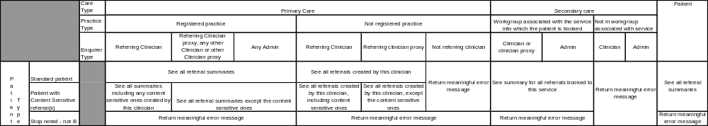
Figure 2 - validation rules for outline information

Validation rules for Choose and Book referral detail information

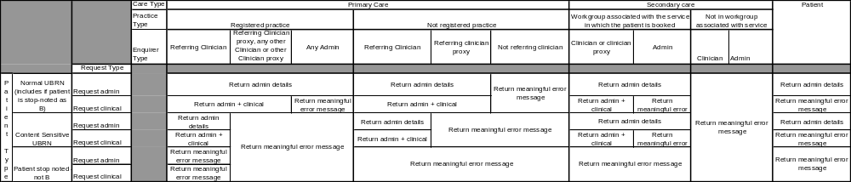
Figure 3 - validation rules for detail information

